2.97: For the purpose of doing all four parts with the least repetition of algebra, quantities will be denoted symbolically. That is, let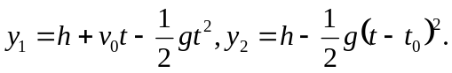 In this case, 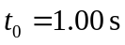. Setting 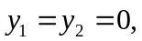expanding the binomial 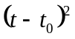and eliminating the common term 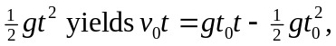which can be solved for t;
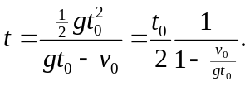
Substitution of this into the expression for 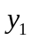 and setting 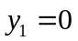and solving for h as a function of v₀ yields, after some algebra,
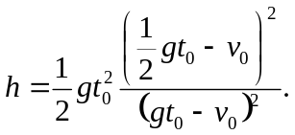

a) Using the given value 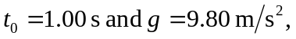

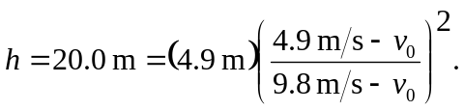

This has two solutions, one of which is unphysical (the first ball is still going up when the second is released; see part (c)). The physical solution involves taking the negative square root before solving for , and yields 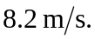

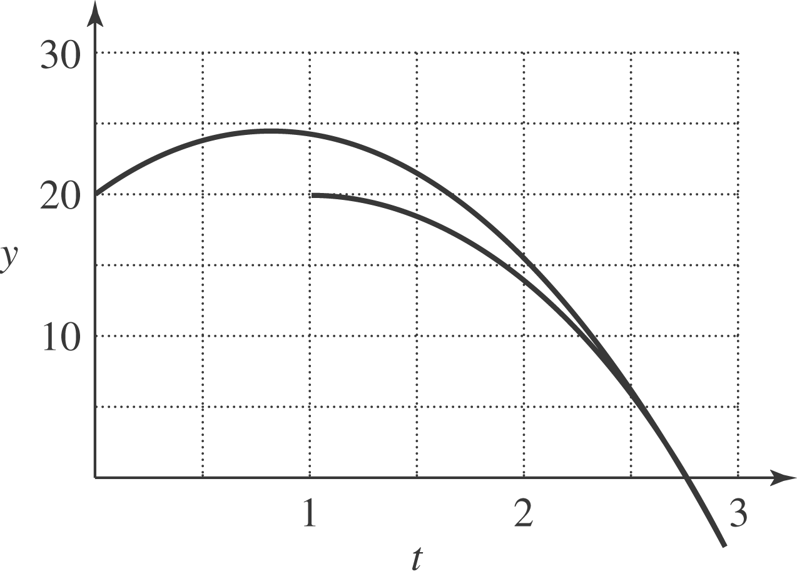
b) The above expression gives for i), 0.411 m and for ii) 1.15 km. c) As v₀ approaches 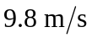, the height h becomes infinite, corresponding to a relative velocity at the time the second ball is thrown that approaches zero. If 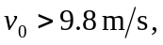 the first ball can never catch the second ball. d) As v₀ approaches 4.9 m/s, the height approaches zero. This corresponds to the first ball being closer and closer (on its way down) to the top of the roof when the second ball is released. If 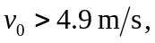 the first ball will already have passed the roof on the way down before the second ball is released, and the second ball can never catch up.

